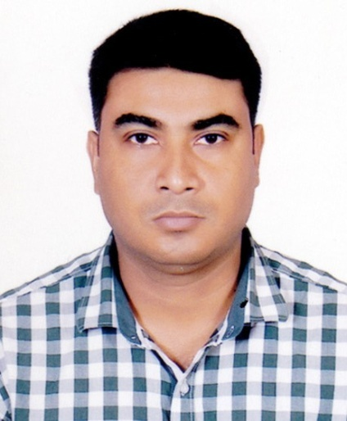

**RESUME**

**OF**

## MD. RUBEL RANA

## Md.Rubel Rana

**Email:** ranahawlader*@gmail.com*

**Contact no: +8801828100300**

**Career Objects:**

Intend to work in challenging and competitive environment where strong sense of responsibility and commitment is required, where dignity of work provides job satisfaction and the place of work provides potential avenues for learning and developing management and other skills and to achieve top level in the hierarchy of career. Particularly in Sales & Customer relationship

**Language Proficiency:**

**English:** Proficiency in writing, reading, speaking & listening.

**Bangla:** Proficiency in writing, reading, speaking & listening

**Computer Skill:**

* MS Office Application: (MS Word, Excel, Access, Power Point).
* General Knowledge in using Software

**Present working:**

Position : Area Sales Manager

Organization : Advance Chemical Industries (Hygiene Products)

Office : 245 Tejgoan Industrial Area, Dhaka-1208

Working Station : Dhaka

Job Duration : 16 June, 2019 to 30 Continue

**Key to Responsibilities:**

* Supervise daily sales & Secondary sales target achievement
* Arrange kick off meeting everyday with his sales team member
* Maintainer administrative activates
* Maintainer good relationship with traders, distributors & sales officer
* Enhance excellent trade relation with different traders & customers
* Implement organizational policies & strategies to complete with competitor
* Forecast market demand & achieve sales target
* Ensure sustainable growth of own market share
* Setting revenue target for team members and dealer of the assigned region
* Review the targets on weekly, monthly and quarterly basis and implementing effective ways to improve sales
* Negotiate and close agreements with large corporate/institutional customers
* Negotiate and contract sales volume, Payment terms, Sales policies with dealers to ensure best performance

**Experienced**

Position : Assistant Executive

Organization : Bashundhara Paper Mills Ltd (Tissue, Ex-Book, A4 Paper & Hygiene)

Office : Plot-3, Block-C, Umme Kulsum Road, Bashundhara R/A, Dhaka-1229

Station : Dhaka

Job Duration : 17 February, 2013 to 16 June 2019

**Key to Responsibilities:**

* Supervised daily sales & Secondary sales target achievement
* Arranged kick off meeting everyday with his sales team member
* Maintained good relationship with traders, distributors & sales officer
* Enhanced excellent trade relation with different traders & customers
* Implement organizational policies & strategies to complete with competitor
* Forecast market demand & achieve sales target

**Educational Qualification:**

**Masters of Social Science (M.S.S)** Completed in political science, grade point in 2.88 out of 4. From Tejgoan College in Dhaka under National University Bangladesh

**Bachelor of Social Science (B.S.S)** Completed in Social science, 2nd Division. From Government Bangla College in Dhaka under National University Bangladesh

**Higher Secondary School Certificate (H.S.C)** Completed in business Studies, grade point in 2.60 out of 5 From Gov’t Bangla College in Mirpur under Dhaka Borad

**Secondary School Certificate (S.S.C)** Completed in business Studies, grade point in 3.00 out of 5 From Adarsha High School in Mirpur under Dhaka Borad

**Training:**

* I have completed **“Archery Training course- 2005”** from Bangladesh archery

Federation, Dhaka stadiums Dhaka

* I have completed The “**Diploma in Fashion Merchandising**” Course from “Asian

Fashion International ltd” in January from June 2006.

* I have completed The **“Diploma in Survey (Aminship)”** Course from Moinamati technical training institute. Held in 2011
* I have completed **“Archery Judges Seminar- 2011”** from Bangladesh archery

Federation, Dhaka stadiums, Dhaka

**Sports Knowledge:**

* **National judge**

Federation of Film Societies Bangladesh

* **Senior scorer**

1st south Asian Archery championship Bangladesh 2006

* **Ex. Player**

Bangladesh archery Federation

**Personal Details:**

Name : **Md. Rubel Rana**

Father's name : Md. Adaam Ali Hawlader

Mother's name : Rizia Khatun

Date of birth : 01 October 1986

Sex : Male

Nationality : Bangladeshi (by Birth)

Religion : Islam

Marital Status : Married

Height : 5’’5’

Blood Group : B+ (Positive)

National ID : 3704085509

|  |  |
| --- | --- |
| **Present Address:**  House No: 15, Road: 11/1,  Block: B, Section - 10  Mirpur, Dhaka – 1216 | **Permanent Address:**  Village: Chotogourichanna,  P.O: Mirmohol, P.S: Barguna  District: Barguna |

**Reference:**

|  |  |
| --- | --- |
| **Syed Abdullah Shahid**  Ex. Joint District Judge,  129/D, West Dhanmondi,  Dhaka  **+**8801712528045 | **Md. Lutfor Rahman**  Proprietor  Shatabdi Enterprise,  Mirpur –10, Dhaka.  **+**8801715580260 |

## Declaration Authenticity:

## I am, Rubel Rana, hereby declare that the above-furnished information is true to the best of my knowledge and belief.

**You’re faithfully**

(Md. Rubel Rana)